PRESS RELEASE | 16 May 2012

Effects As Good As The Avengers
For 0.0001% Of The Price

MJ Hibbett & The Validators are releasing a special effects laden blockbuster video for their new single 'The Battle Of Peterborough' which challenges 'The Avengers' for science fiction thrills with a budget approximately ten million times smaller.
"Clearly 'The Avengers' is a bit longer than our song," says MJ Hibbett, "But I still don't see why Joss Whedon had to spend 260 million dollars on it. We did ours at home using camera phones and it looks incredibly lifelike."
In 'The Battle Of Peterborough' Space Dinosaurs obliterate townships and villages all along the A47 before wrecking havoc in Peterborough itself. It's hard to believe that the whole thing was filmed by waving plastic dinosaurs in front of Google Street View, such is the terrifying realism on display.
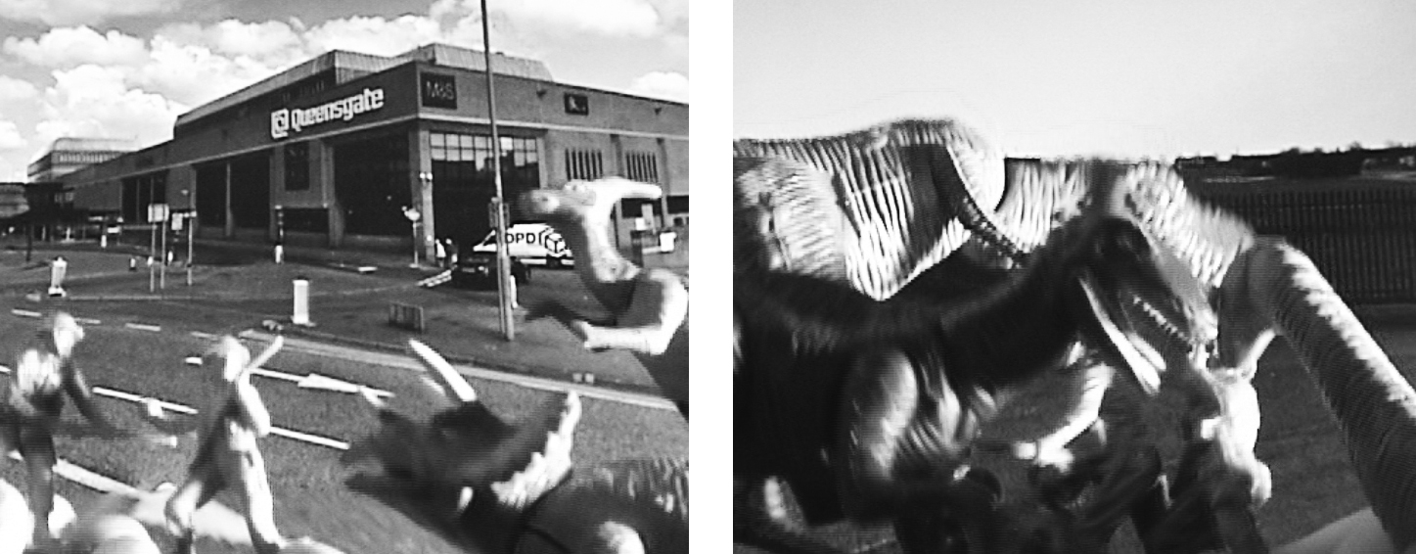
(screenshots of terrifying realism)
The single is taken from the band's new album, 'Dinosaur Planet', which has been received with great acclaim in the science fiction community. SFX magazine said it was "Jeff Wayne's new competition", Comics Alliance called it "The Greatest Story (About Space-Faring Dinosaurs) Ever Told" and io9 said it was "the space dinosaurs vs. giant robots rock opera you've been waiting for". It's been greeted more with confusion by musical reviewers, notably David Hepworth in Word Magazine who said simply "You have to admire their nerve."

free download single released May 28th from www.dinosaurplanet.co.uk/peterborough
continues overleaf...
Further Information
"The Battle Of Peterborough" will be released on May 28th as a free download single at http://www.dinosaurplanet.co.uk /peterborough
The video can be seen now at the above link, or on YouTube at http://www.youtube.com/watch?v=Ugs5AoT3pJo
Apart from MJ Hibbett & The Validators the song also features Claire Gibb as General Muriel Truelove ("this is where we shall draw the line..."), Jonny Yeah as The Narrator and Bob Fischer as The Newsreader.
Background
'Dinosaur Planet' started off as an Edinburgh Fringe show. MJ Hibbett was inspired to write it after seeing a slightly disappointing one-man version of Jeff Wayne's 'War Of The Worlds'.
Guest stars include Phil Wilson (The June Brides), Chris T-T, Keith Top Of The Pops, BBC One continuity announcer Claire Gibb and BBC Radio Tees DJ Bob Fischer.
MJ Hibbett & The Validators have performed live on Radio One, had a Record Of The Year in Rolling Stone, an Album Of The Day on 6Music, toured all around the world and very narrowly avoided writing an autobiography. They're probably best known for 'Hey Hey 16K', the world's first ever internet viral hit.
All of the album illustrations were drawn by John Allison, creator of the long running online comics Bad Machinery, Bobbins and Scarygoround.
www.dinosaurplanet.co.uk

