PRESS RELEASE | 22 June 2012

New version of album released for the easily alarmed

MJ Hibbett & The Validators are pleased to announce the release of 'Dinosaur Planet (REDUX)', a new version of their latest album created especially for those who found a full-cast science fiction rock opera about space dinosaurs too much to cope with.

"When we released the original 'Dinosaur Planet' we discovered that not everybody actually wants an hour long thrill-ride of dinosaurs, giant robots and good quality academic research," says lead singer MJ Hibbett. "Apparently they'd rather have a nice non-threatening album of straightforward unconnected songs that you don't have to listen too hard to. This is for them."
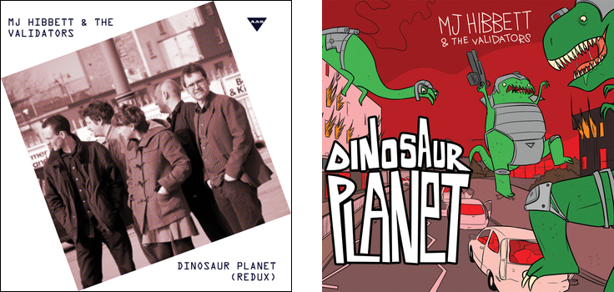
(l-r) new non-threatening cover, original too exciting cover
All of the original album's dramatic interludes have been taken out and musical tracks have been edited to remove any trace of plot, but some songs have had to be removed completely. For example, it was impossible to edit out the drama and thrill-power of the six minute orchestral extravaganza 'For The Fate Of The Earth', while the sound of hundreds of gigantic lizards dancing the hornpipe in 'Dinosaurs Talk Like Pirates' was deemed irredeemably exciting.

What's left is 20 minutes of excellent, if unrelated, music featuring a plethora of guest stars. Listeners can now enjoy guest appearances by the likes of Phil Wilson from the June Brides and Chris T-T without having to worry about them getting blown-up, eaten, or stamped on.

To be completely safe the band have also taken the precaution of removing the amazing cover artwork by award winning cartoonist John Allison, replacing it with a straightforward photograph of the band. "The fully illustrated booklet had to go too," says a contrite MJ Hibbett. "It was just too awesome and, for that, we can only apologise."

'Dinosaur Planet (REDUX)' has its own specially designed information-lite website at http://www.dinosaurplanet.co.uk/redux, where the album can be downloaded at the reassuringly expensive price of £10.00. The original 'Dinosaur Planet' can be downloaded from http://www.dinosaurplanet.co.uk for £5.00.

For more information contact MJ Hibbett on 07787 560908 or mjhibbett@gmail.com
continues overleaf...
Background
The original 'Dinosaur Planet' has been called "Jeff Wayne's new competition" by SFX, "the space dinosaurs vs. giant robots rock opera you've been waiting for" by io9 and "The Greatest Story (About Space-Faring Dinosaurs) Ever Told (In a Rock Opera)" by Comics Alliance.
The NME has, as yet, not reviewed it.
'Dinosaur Planet' started off as an Edinburgh Fringe show. MJ Hibbett was inspired to write it after seeing a slightly disappointing one-man version of Jeff Wayne's 'War Of The Worlds'.
Guest stars include Phil Wilson (June Brides), Chris T-T, Keith Top Of The Pops, BBC One continuity announcer Claire Gibb and BBC Radio Tees DJ Bob Fischer.
MJ Hibbett & The Validators have performed live on Radio One, had a Record Of The Year in Rolling Stone, an Album Of The Day on 6Music, toured all around the world and very narrowly avoided writing an autobiography. They're probably best known for 'Hey Hey 16K', the world's first ever internet viral hit.
Revised Tracklisting  1. Dinosaur Planet  2. My Grandad Is Nuts  3. Strangely Attractive  4. Don't, Darren, Don't  5. Here Come The Dinosaurs  6. A Little Bit  7. The Battle Of Peterborough  8. Please Don't Eat Us  9. Literature Search  10. We Are The Giant Robots | Original Tracklisting  1. Theme From Dinosaur Planet (overture)  2. Norwich Central Police Station  3. Don't, Darren, Don't  4. Theme From Dinosaur Planet  5. The University Of Space  6. A Little Bit  7. The Secret Army Base  8. Here Come The Dinosaurs  9. Just The Place To Start  10. The Theory Of A Dinosaur Planet  11. My Grandad Is Nuts  12. Whither The War Room?  13. The Battle Of Peterborough  14. Grandad's House  15. My Theory Of A Dinosaur Planet  16. Arrival Of The Giant Robots  17. We Are The Giant Robots  18. A Moment Of History  19. Dinosaurs Talk Like Pirates  20. What Is Your Business Here?  21. We Are The Dinosaurs  22. Some Kind Of Relationship  23. Literature Search  24. Teething Trouble  25. Strangely Attractive  26. Our Little Problem  27. Please Don't Eat Us  28. To Battle!  29. For The Fate Of The Earth  30. The Battle Won  31. A Little Bit More  32. The End... ?  33. Theme From Dinosaur Planet (reprise)
www.dinosaurplanet.co.uk
www.dinosaurplanet.co.uk/redux

